Safeguarding Framework

The Resource and Support Hub

Author: Nastasya Gecim

Date: February 2020

**Table of contents**

Executive Summary 3

1. Background and rationale 3

What is safeguarding? 3

Objectives of the Framework 4

Our safeguarding commitments 5

Scope 6

2. Safeguarding measures for RSH 6

The purpose of the Safeguarding Framework for RSH 6

Ethical standards 6

Reporting a safeguarding concern 7

Responding to a safeguarding concern 7

ANNEX 1: Options Child and Vulnerable Adult Safeguarding Policy 10

ANNEX 2: Options Code of Conduct 11

# Executive Summary

Acknowledging the fundamental importance of safeguarding to the successful delivery of this programme, the Resource and Support Hub Safeguarding Framework explains how safeguarding policies and procedures will be developed, implemented, monitored and refined over time and across the programme. It describes the preventative measures that will be taken to ensure the programme staff and associates do not cause harm, and provides clear guidance for instances where this does happen. It sets out the roles and responsibilities of groups and individuals within the team, demonstrating how safeguarding is the responsibility of everyone in the programme.

# Background and rationale

## What is safeguarding?

For the purposes of framing its own internal safeguarding arrangements, the Resource and Support Hub (RSH) defines safeguarding in the following way:

**Safeguarding is an ethical approach and set of practical measures adopted by organisations to promote the safety and wellbeing of everyone involved in the delivery and receipt of humanitarian aid and development assistance, and to protect them as far as possible from all forms of harm, including sexual exploitation and abuse and sexual harassment, that might result from their involvement in or contact with the organisation**.[1]

The Hub also uses the following international definitions for related concepts:

**Sexual Exploitation:** Any actual or attempted abuse of a position of vulnerability, differential power, or trust for sexual purposes. Includes profiting monetarily, socially, or politically from sexual exploitation of another. Under UN regulations it includes transactional sex, solicitation of transactional sex and exploitative relationship.[2]

**Sexual Abuse:** The actual or threatened physical intrusion of a sexual nature, whether by force or under unequal or coercive conditions. It includes sexual assault (attempted rape, kissing / touching, forcing someone to perform oral sex / touching) as well as rape. Under UN regulations, all sexual activity with someone under the age of 18 is considered to be sexual abuse, regardless of the age of majority or consent locally. Mistaken belief in the age of a child is not a defence.[3]

**Sexual Harassment:** A continuum of unacceptable and unwelcome behaviours and practices of a sexual nature that may include, but are not limited to, sexual suggestions or demands, requests for sexual favours and sexual, verbal or physical conduct or gestures, that are or might reasonably be perceived as offensive or humiliating.[4]

SEA is a breach of the provisions of the UN Secretary General’s Bulletin (Special measures for protection from sexual exploitation and sexual abuse), and is “Conduct or behaviour of a sexual nature when this conduct or behaviour amounts to either sexual exploitation or sexual abuse as defined in ST/SGB/2003/13”.[5]

**Protection from Sexual Exploitation and Abuse (PSEA)** is the term used by the UN and NGO community to refer to measures taken to protect people from sexual exploitation and abuse by their own staff and associated personnel.[6]

Safeguarding is primarily a preventative approach and involves organisations meeting their responsibilities as defined in international laws and instruments, national codes and organisational policies, for example, to ensure the rights to protection, equal treatment and non-discrimination of staff and associates, as well as all stakeholders who come into contact with our programme. Safeguarding means treating everyone with dignity and fairness and creating environments and relationships between colleagues and between staff and community members that are respectful.

## Objectives of the Framework

This Safeguarding Framework outlines RSH’s overarching approach to safeguarding against SEAH and describes how safeguarding policies and procedures will be developed, refined and implemented throughout the programme. The Framework will:

* Complement Options’ safeguarding policy (see Annex 1) by providing additional and context-specific guidance to the programme team. The framework does not replace Options’ existing policy.
* Outline how RSH’s commitment to safeguarding will be implemented and managed across the programme to ensure donor compliance.
* Outline clear roles and responsibilities within the RSH team for different aspects of the safeguarding commitment that the programme has made.

The RSH approach to safeguarding is aligned with DFID’s own safeguarding principles[7], namely:

* Everyone has responsibility for safeguarding.
* Do no harm.
* Organisations have a safeguarding duty of care to beneficiaries, staff and volunteers, including where down-stream partners are part of delivery. This includes children and adults in the community who are not direct beneficiaries but may be vulnerable to abuse.
* Act with integrity, be transparent and accountable.
* Act in a way that seeks to care for and protect the rights of children and adults and act in their best interests.
* A child is defined as someone under the age of 18 in line with The United Nations Convention on the Rights of the Child (UNCRC).
* All individuals (including children and adults) shall be treated equally, irrespective of ethnicity, gender, religion/or none, sexual orientation or disability or other aspect of identity.
* Organisations that work with children and/or adults should apply a safeguarding lens to their promotional communications and fundraising activities.
* Survivor-centred e.g. by prioritising the needs and wishes of the survivor.[8]
* Use information and resources in a safe and responsible way. This includes the exercise of due care in all matters of official business, and not divulging confidential information.
* Ensure that personal and professional conduct is, and is seen to be, of the highest standard and in line with the Code of Conduct.
* Never engage in any abuse or exploitative relationships – sexual, emotional, financial or employment-related.
* Refrain from any involvement in criminal or unethical activities or that contravene human rights.
* Ensure that another adult is present when working in the proximity of children and also adults where they may be at risk or vulnerable.

## Our safeguarding commitments

It is vital that RSH takes all reasonable steps to prevent social and environmental harm from occurring and responds appropriately when actual or potential harm or allegations of harm do occur. RSH acknowledges that there are potential risks to specific groups through our work, including through RSH team members and associates engaging with victims and survivors of SEAH as well as delivering services in country. Attention will be paid to the welfare of all children and adults, and particularly those who may be at risk such as survivors of violence, and/or people with disabilities, for example.

In order to do this, RSH will at all times adopt an inclusive, survivor-centred, child-centred and Do No Harm approach.

By recognising the potential risk caused by our team members and programme operations, and in order to protect these individuals, RSH is committed to:

**Safeguarding children:** by minimising the risk of intentional or unintentional harm, abuse and exploitation of children and within programme operations, and responding appropriately to any actual or potential harm.

**Safeguarding adults:** by protecting the safety and well-being of all adults and providing additional measures to protect those at risk and less able to defend themselves from harm.

**Safeguarding staff:** by avoiding ambiguous workplace situations and behaviours, which may be misinterpreted and potentially lead to false allegations against them, as well as ensuring they are treated with dignity and respect.

By demonstrating our genuine commitment to safeguarding children, adults and staff, we aim to prevent cases of abuse from happening which may tarnish RSH’s reputation and affect our ability to continue working.

## Scope

This Framework applies to all RSH individuals employed on a full or part time contract in the UK or overseas, consultants contracted through the STTA pool and individual members engaging with the programme through governance and accountability structures such as the Executive Steering Committee (ESC), the Consortium Advisory Group (CAG) and the National Expert Boards in each target country (NEB). These are collectively referred to as ‘team members and associates’ in this Framework.

# Safeguarding measures for RSH

As Options is the contractual lead for RSH, the programme must comply with Options’ policies, namely the Child and Vulnerable Adult Safeguarding Policy and Code of Conduct. (See Annexes 1 and 2).

In order to make sure that there is consistency between the different consortium partners, the programme has developed this Safeguarding Framework to draw together the main elements of the programme’s commitment and approach to safeguarding, while ensuring it is relevant to this specific programme. The framework also practically sets out roles and responsibilities for implementing different aspects of the policy and meeting the commitments described above.

## The purpose of the Safeguarding Framework for RSH

The purpose of applying a Safeguarding Framework for RSH, including in the target countries where the programme is operational, is to prevent harm and where safeguarding issues and incidents do arise, ensure all staff and stakeholders know how to report actual or potential harm. RSH will support this by having an approach to safeguarding that is contextually relevant for team members and associates operating in their respective implementation locations.

Further, the programme’s focus on supporting organisations in the international aid sector to strengthen their safeguarding against SEAH, and in engaging with survivors of SEAH, requires particular safeguarding measures to ensure the programme does not cause harm.

## Ethical standards

* The programme will implement high ethical standards in research, evaluation and programme implementation. The following principles apply to all groups involved in our work, including staff, consultants, researchers, participants and other research and programme stakeholders, unless otherwise specified.
* Our work should lead to clear social development benefits in people's lives.
* Our work is conducted to a high standard in ways that are fit for purpose and ensure only the gathering of information that is relevant to the goals of our work.
* Harm to all groups involved in our work is avoided.
* We are inclusive, ensure that marginalised groups are not excluded and are respectful of and informed by cultural differences and sensitivities.
* Participants take part voluntarily, based on valid informed consent.
* We compensate research participants for their involvement in locally appropriate ways which do not put them at risk of harm.
* Personal information is treated confidentially, and the privacy and anonymity of participants is preserved. The evaluator will be clear in the introduction that if an interviewee reveals something that raises concern, then confidentiality will need to be breached. They will be clear about this and the implications of any disclosure. This would inform any consent obtained.
* We publish and communicate research and evaluation finding and endeavour to feedback findings to the participants.
* We adhere to national and local ethics approval processes within the countries we work.
* We adhere to data protection protocols for the management of personal data.

## Reporting a safeguarding concern

Staff members and associates are encouraged to report a safeguarding concern to the safeguarding points of contact at national (NAs) or overall programme level (Deputy Team Leader). If a staff member does not feel comfortable reporting directly to these points of contact, they can report their concern to the Deputy Team Leader through the [reports@rshub.org.uk](mailto:reports@rshub.org.uk).

In addition, RSH follows a **Speak Up approach** whereby it encourages staff to raise concerns and provides multiple reporting channels in order to reduce any potential barriers to reporting. It is therefore possible for RSH staff to report using **DFID’s Reporting Concerns** inbox at [reportingconcerns@dfid.gov.uk](mailto:reportingconcerns@dfid.gov.uk) or confidential reporting hot line +44 (0)1355 843 747.

RSH will set up specific reporting mechanisms at country level, including existing reporting pathways where possible, that are contextually appropriate. These will be agreed at the kick-off meeting in each national office.

## Responding to a safeguarding concern

Once a safeguarding concern has been reported, as a first priority, the Deputy Team Leader will make sure that the person affected by the alleged abuse is at no risk of further harm and has any urgent needs met before following the steps outlined in this framework.

The process below depicts the steps taken when a safeguarding concern is identified and reported.

**Figure 1: Steps to follow when a safeguarding concern is reported to RSH**

The **case management team** is made up of a small number of individuals within the consortium. This group is responsible for making an assessment of the case and deciding next steps, such as whether further information gathering is required, whether an investigation needs to be commissioned, who should lead and/or be involved in the investigation, and whether the relevant authorities should be informed.

**Figure 3: Basic flow chart for when a safeguarding concern is reported to DFID**

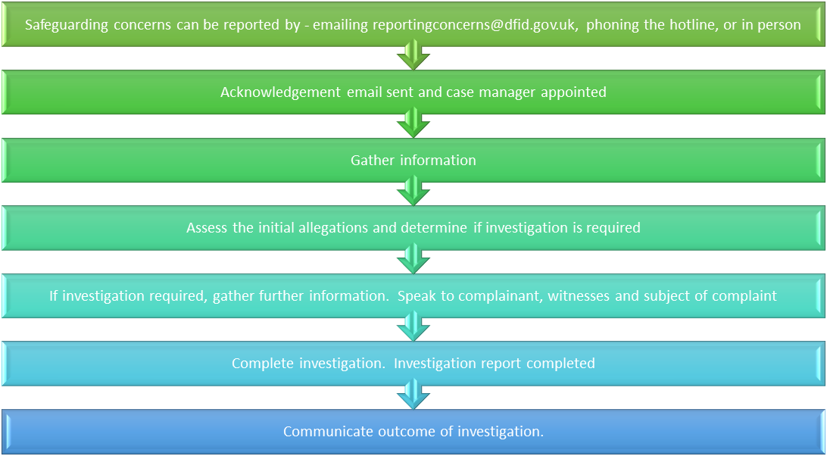

# ANNEX 1: Options Child and Vulnerable Adult Safeguarding Policy



# ANNEX 2: Options Code of Conduct



1. RSH working definition adapted from the Bond Working Group 2 draft definition April 2018
2. United Nations (2017) Glossary on Sexual Exploitation and Abuse. Second Edition. (<https://hr.un.org/sites/hr.un.org/files/SEA%20Glossary%20%20%5BSecond%20Edition%20-%202017%5D%20-%20English_0.pdf>)
3. Ibid.
4. United Nations (2018) Intensification of efforts to prevent and eliminate all forms of violence against women and girls: sexual harassment (A/RES/73/148). UN General Assembly Resolution. (<https://digitallibrary.un.org/record/1660617?ln=en>)
5. UN, 2017.
6. CHS Alliance (2017) PSEA Implementation Quick Reference Handbook (<https://d1h79zlghft2zs.cloudfront.net/uploads/2019/07/PSEA_Handbook.pdf>)
7. Guidance: Enhanced Due Diligence: Safeguarding for external partners (updated 30 January 2020) <https://www.gov.uk/government/publications/dfid-enhanced-due-diligence-safeguarding-for-external-partners/enhanced-due-diligence-safeguarding-for-external-partners#principles-of-safeguarding>
8. See Figure 2 in 4.3 for further detail around how we practically approach this principle on RSH.